—-------------------------------------------------------------------------------------------------------------------

**Task >** Clone the specified repository and deploy the application (running on port 80).

**Getting Started**

My Git repo > psselva02/Devops_capstone (github.com)

**> Pre-installation and cmd for the same -** I have created an Ec2 console and installed the required pkg to perform the task. Please find the link to ref the cmd which I use for this.

[pre_install_pkg.sh · psselva2/Devops_capstone (github.com)](https://github.com/harsanskumaran/Devops_capstone/blob/dev/build/pre_install_pkg.sh)

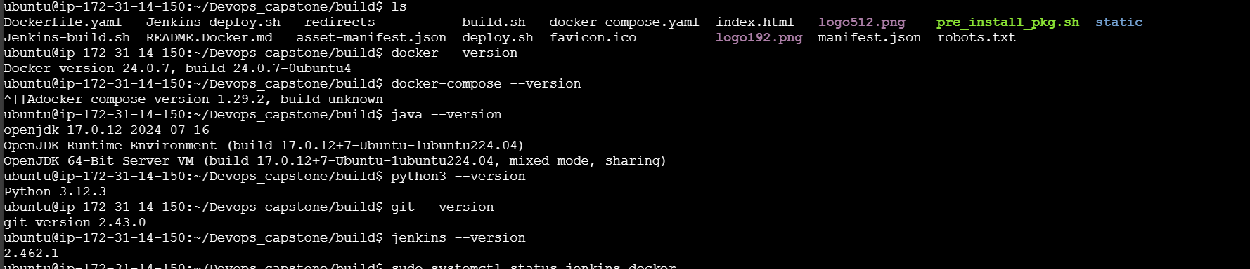

* Jenkins

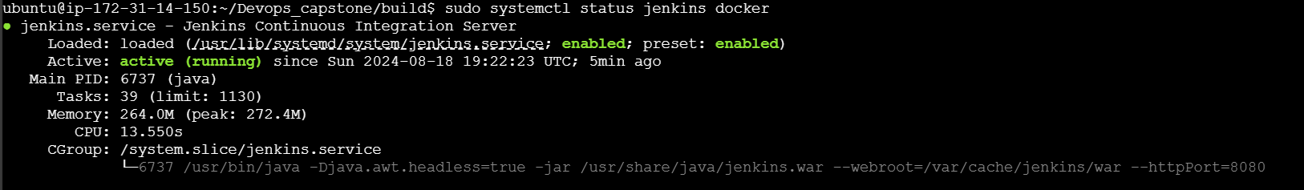

* Docker

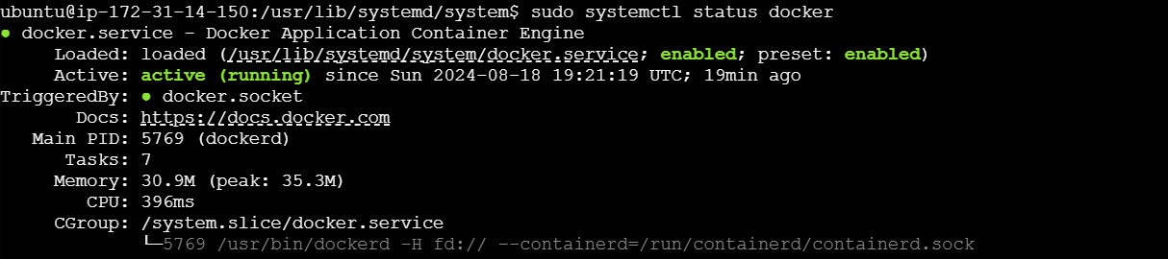

**>**  **Docker part**

I have created dockerfile and docker-compose file according. Please find the script FYR below

* Dockerfile :  [Dockerfile.yaml at dev · psselva02/Devops_capstone · GitHub](https://github.com/harsanskumaran/Devops_capstone/blob/dev/build/Dockerfile.yaml)
* Docker-compose : [docker-compose.yaml at dev · psselva02/Devops_capstone (github.com)](https://github.com/harsanskumaran/Devops_capstone/blob/dev/build/docker-compose.yaml)

**> Bash scripting**

I have written build.sh for building Docker images and deploy.sh for deploying the image to the server.

Please find the script for the same

build.sh :  [build.sh at dev · psselva02/Devops_capstone (github.com)](https://github.com/harsanskumaran/Devops_capstone/blob/dev/build/build.sh)

deploy.sh :  [deploy.sh at dev · psselva02/Devops_capstone (github.com)](https://github.com/harsanskumaran/Devops_capstone/blob/dev/build/deploy.sh)

**> Version Control (Git):**

Pushed the code to GitHub dev branch, utilizing .dockerignore and .gitignore files.

Please find the command-line interface (CLI) for Git commands in below snap

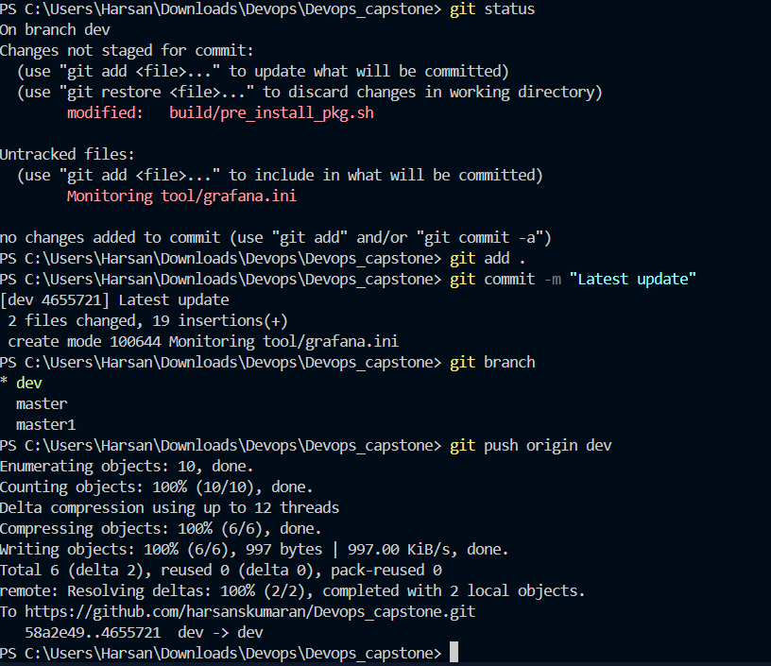

**UI for your ref with 2 branch dev and master**

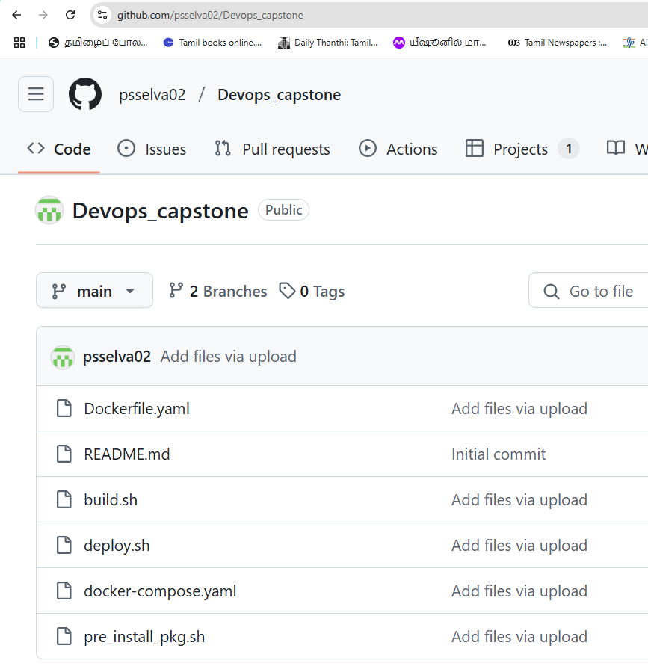

**> Docker Hub Repositories**

Create two repositories: “dev” and “prod” to push Docker images. The “prod” repo was created as private, while the “dev” repo was created as public repo.

* **Dev (Docker Public repo)**

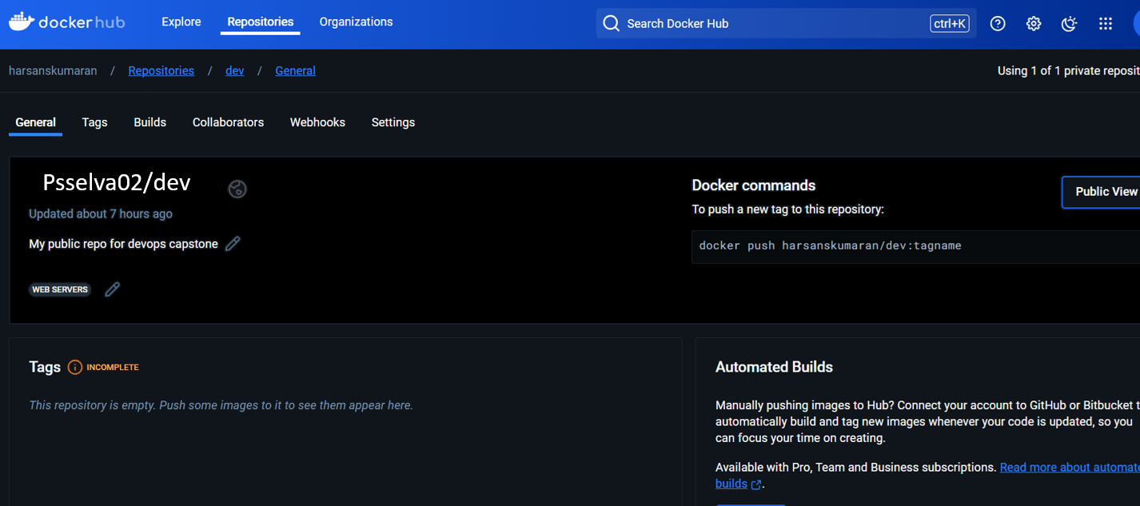

* **Prod (docker private repo)**

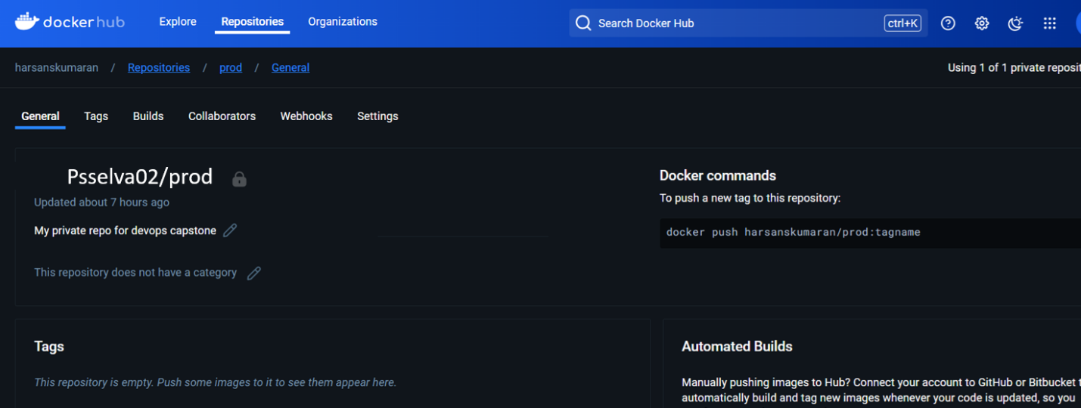

**> Jenkins:**

Installed and configured Jenkins with port no:8081 and built steps as needed to build, push & deploy the application.

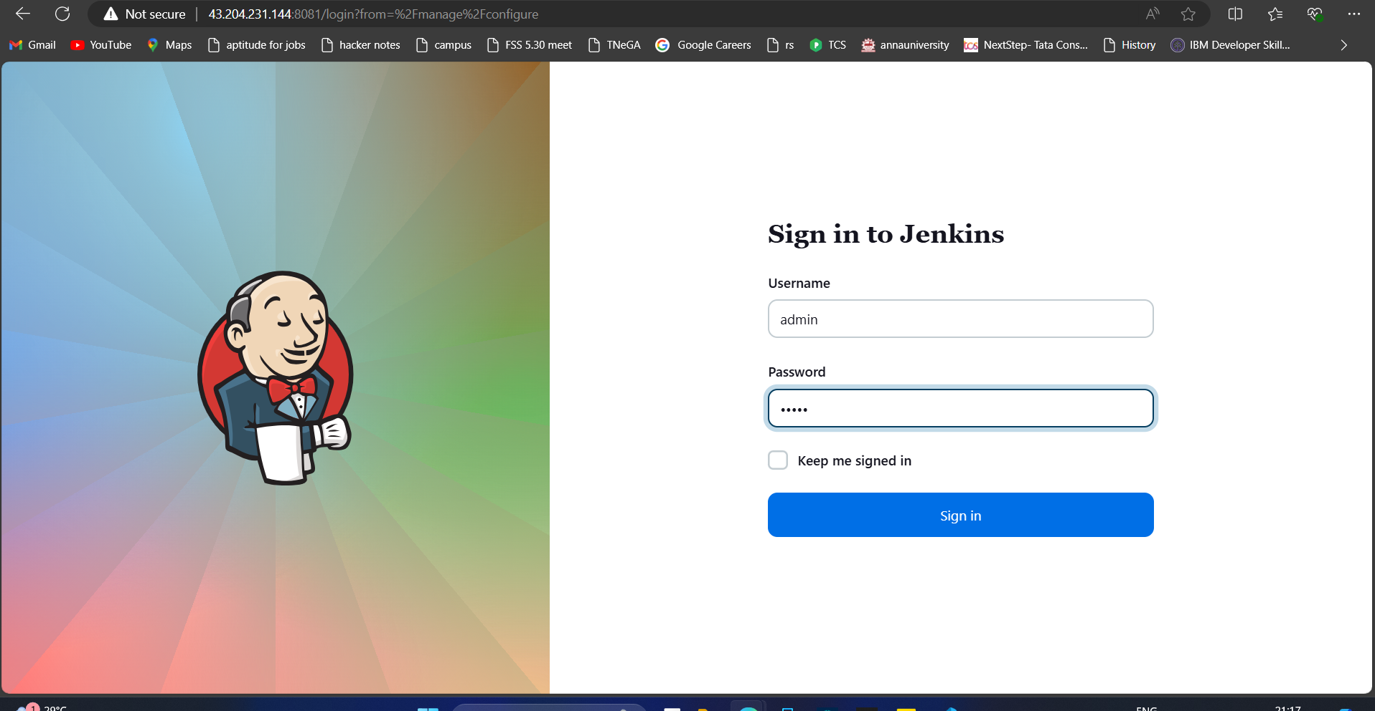

Email config and sent mail successfully with email ext templet plugin

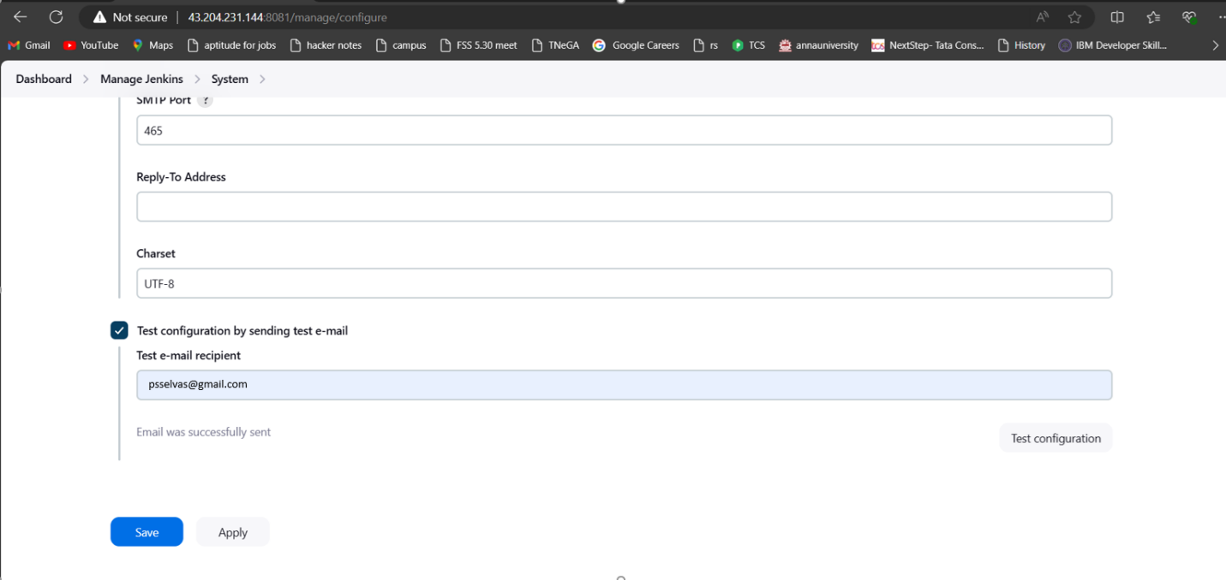

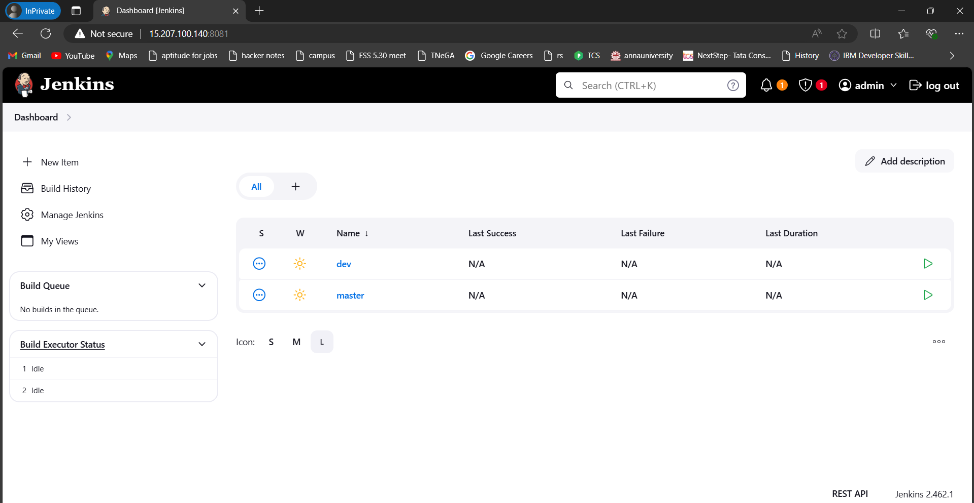

**Connect Jenkins to the GitHub repo with auto build trigger from both dev & master branches.**

* This is my dev project, When the comment happen on git dev repo this pipeline will be started and push the docker image to docker dev repo (public)
* I used GitHub hook trigger for GITScm polling option to connect github dev repo

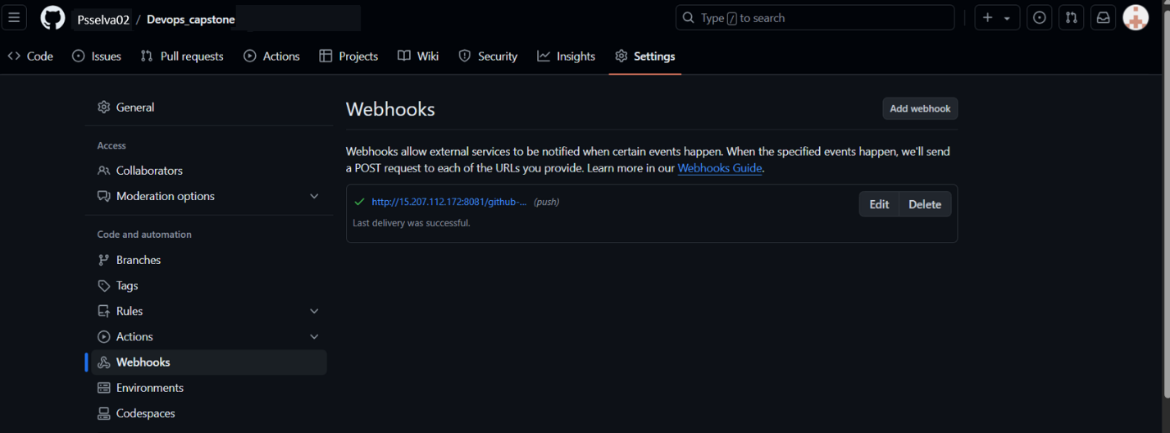

Dev >

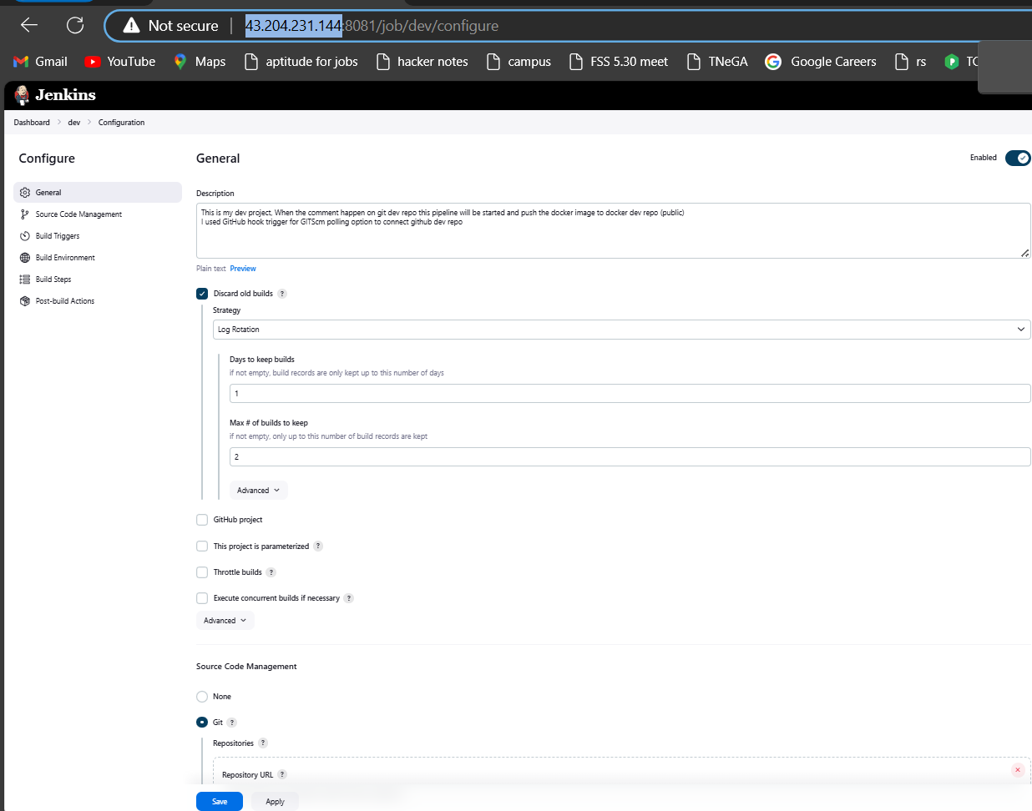

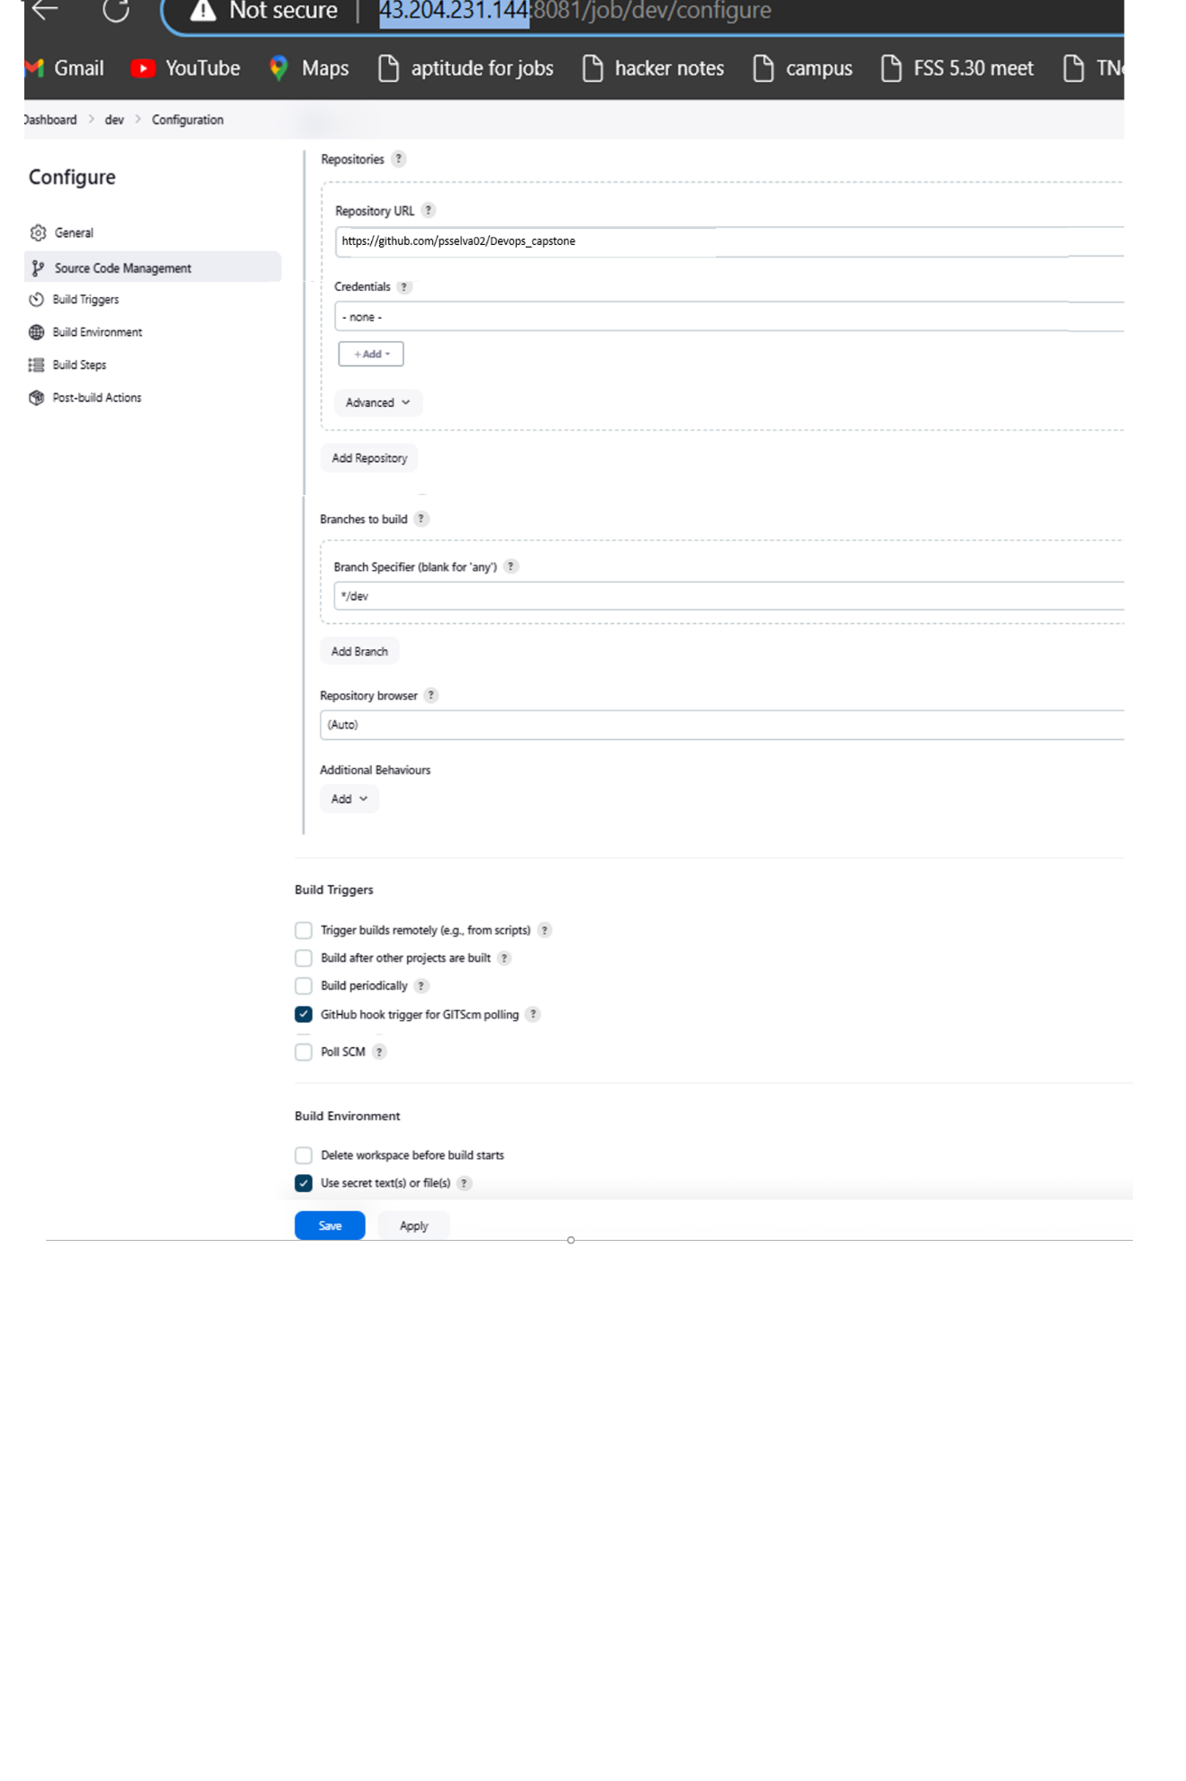

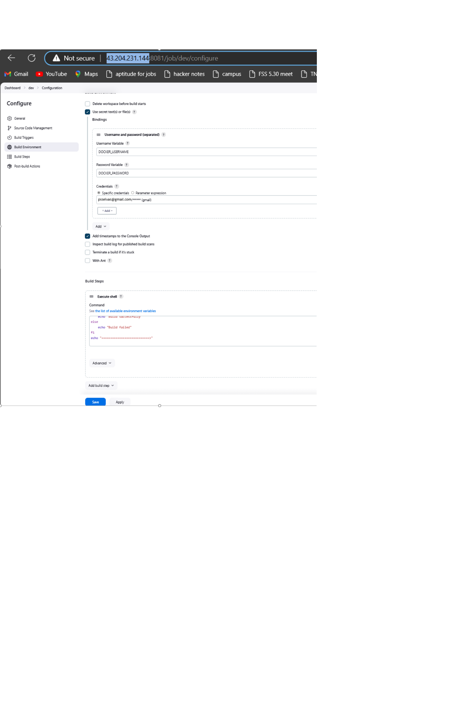

**Build exec part**

**echo "started building docker image"**

**cd build**

**chmod +x build.sh**

**./build.sh**

**if [ $? -eq 0 ]; then**

**echo "Build successfully"**

**else**

**echo "Build failed"**

**fi**

**echo "===========================>"**

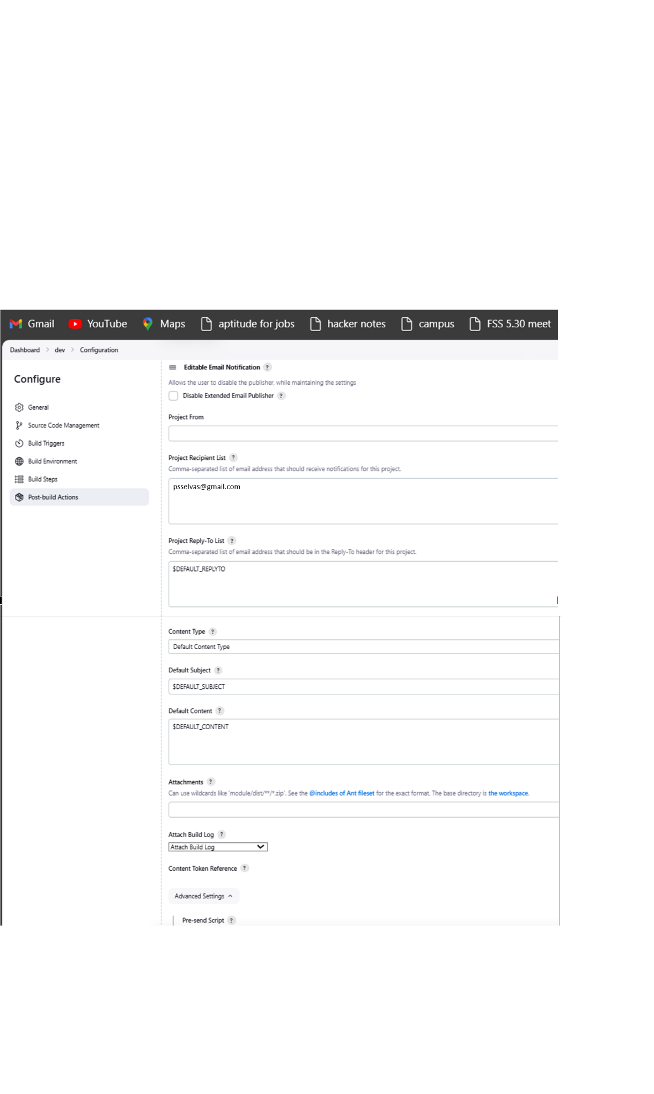

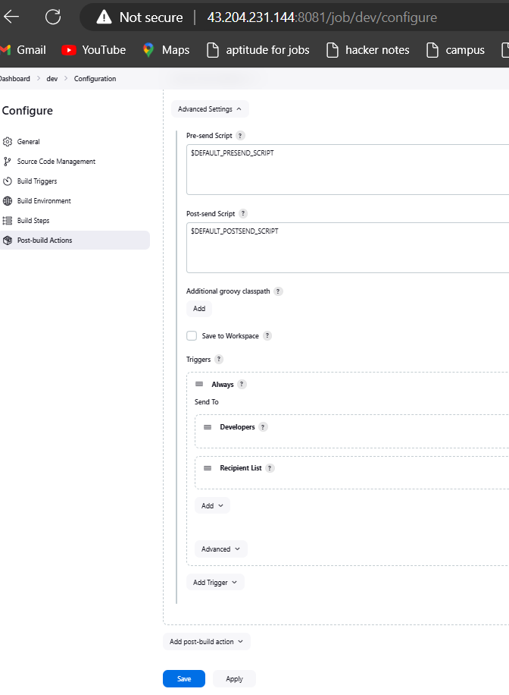

Note > Post exec mail will be triggered accordingly

**Master >**

* This is my master project, When the comment happen on git master repo this pipeline will be started and push the docker image to docker prod repo (private) and up the server
* I used GitHub hook trigger for GITScm polling option to connect github master repo

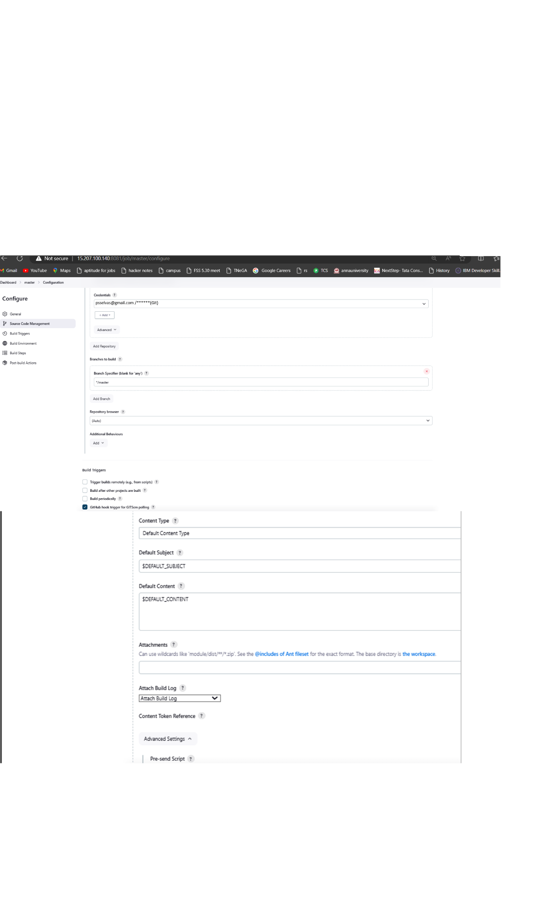

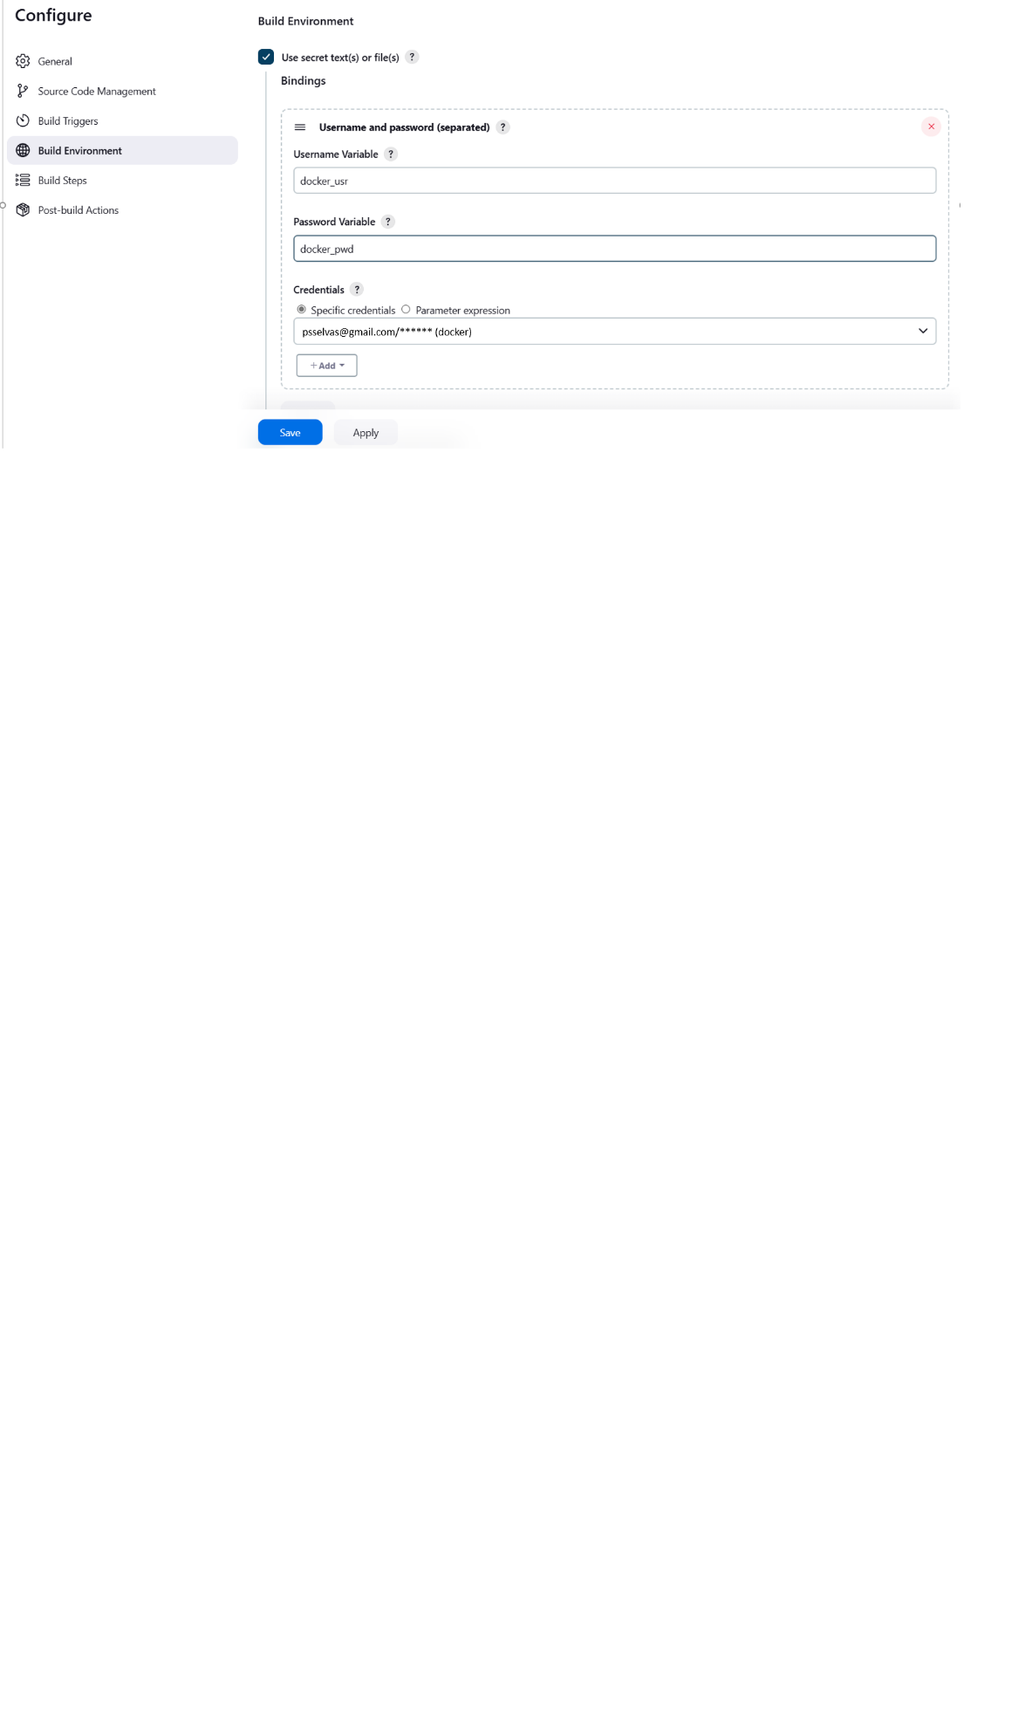

**Build exec:**

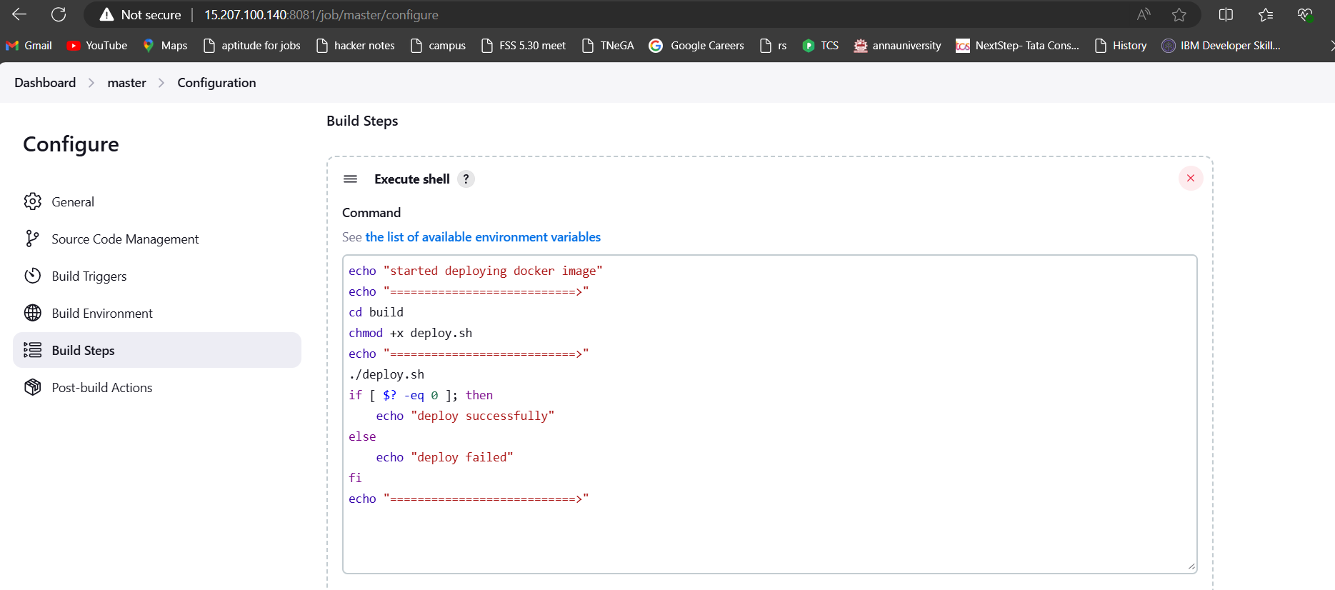

Build script

echo "started deploying docker image"

echo "===========================>"

cd build

echo "===========================>"

chmod +x deploy.sh

echo "===========================>"

./deploy.sh

if [ $? -eq 0 ]; then

echo "deploy successfully"

else

echo "deploy failed"

fi

echo "===========================>"

Note > Post exec mail will be triggered accordingly

**> AWS:**

Launched a t2.micro instance and deployed the created application.

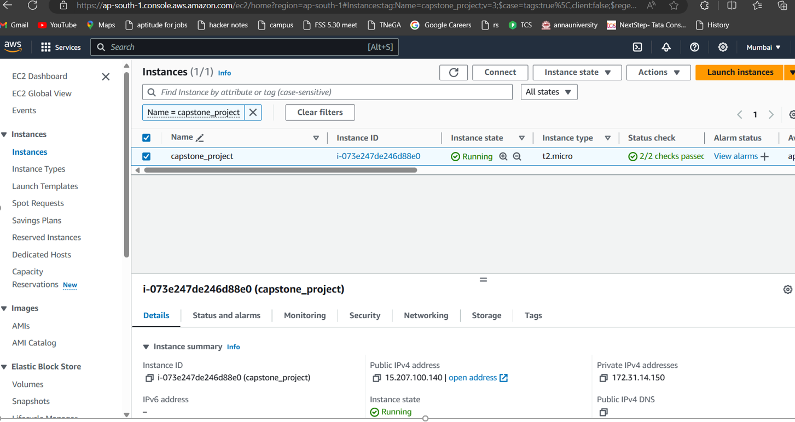

**> Deployed application**

**I have made changes in dev repo and pushed code. Post that jenkins dev project as started and pushing docker image to docker dev repo accordingly.**

* Git clip >

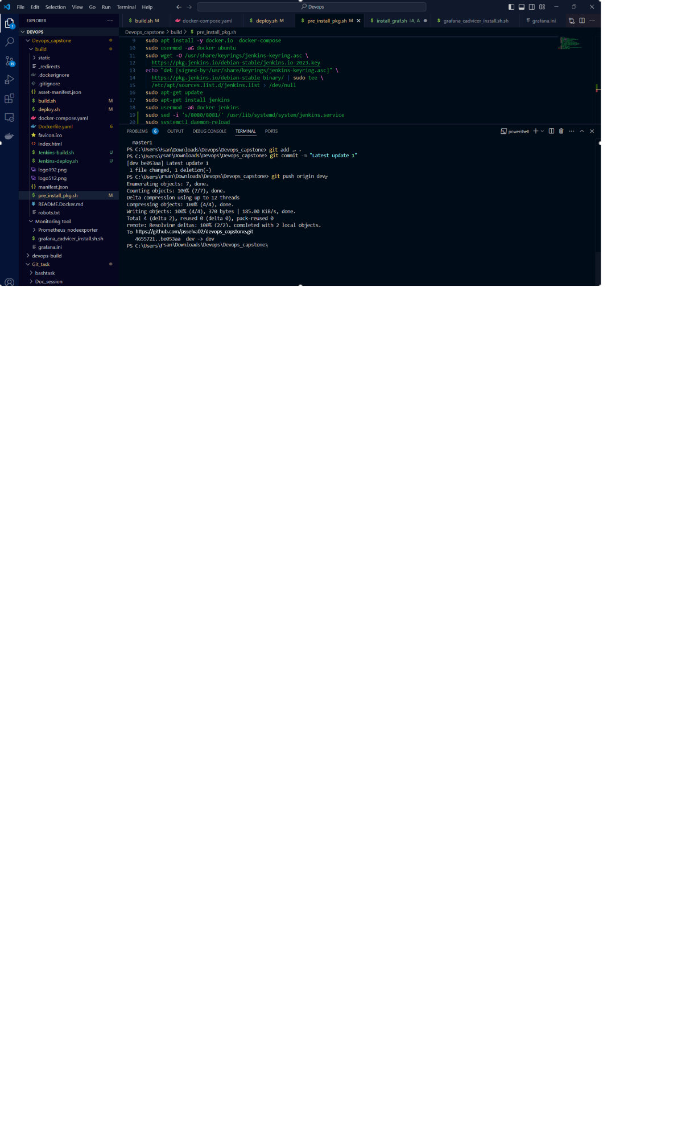

* Jenkins status

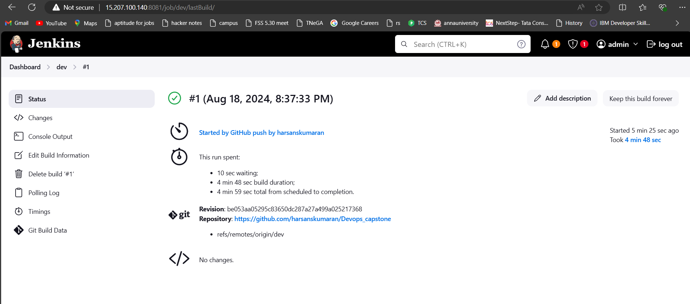

* In console docker image reflected

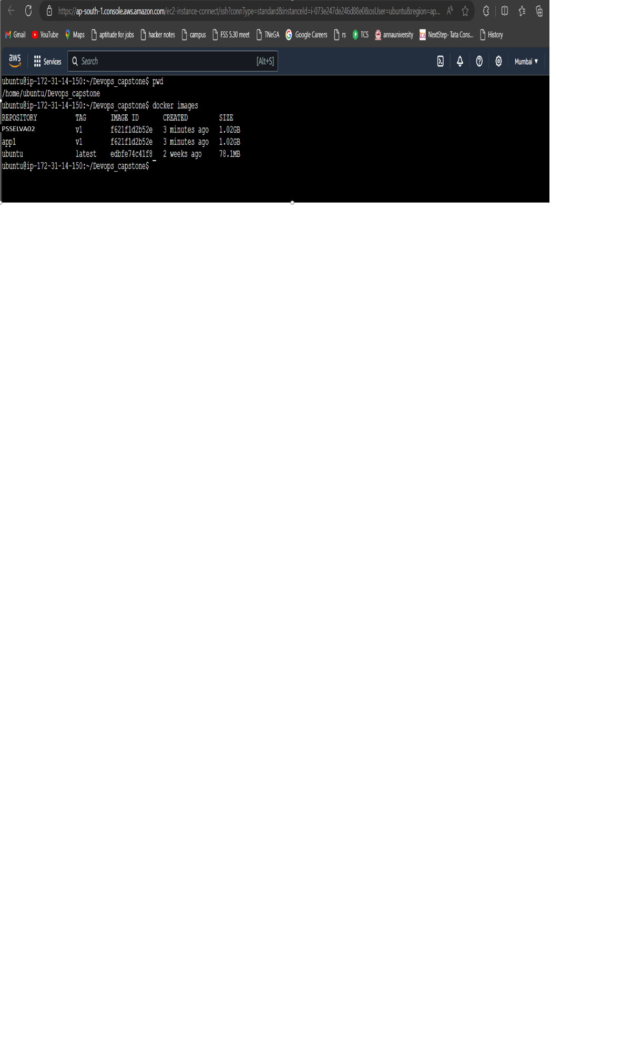

* In dev docker repo

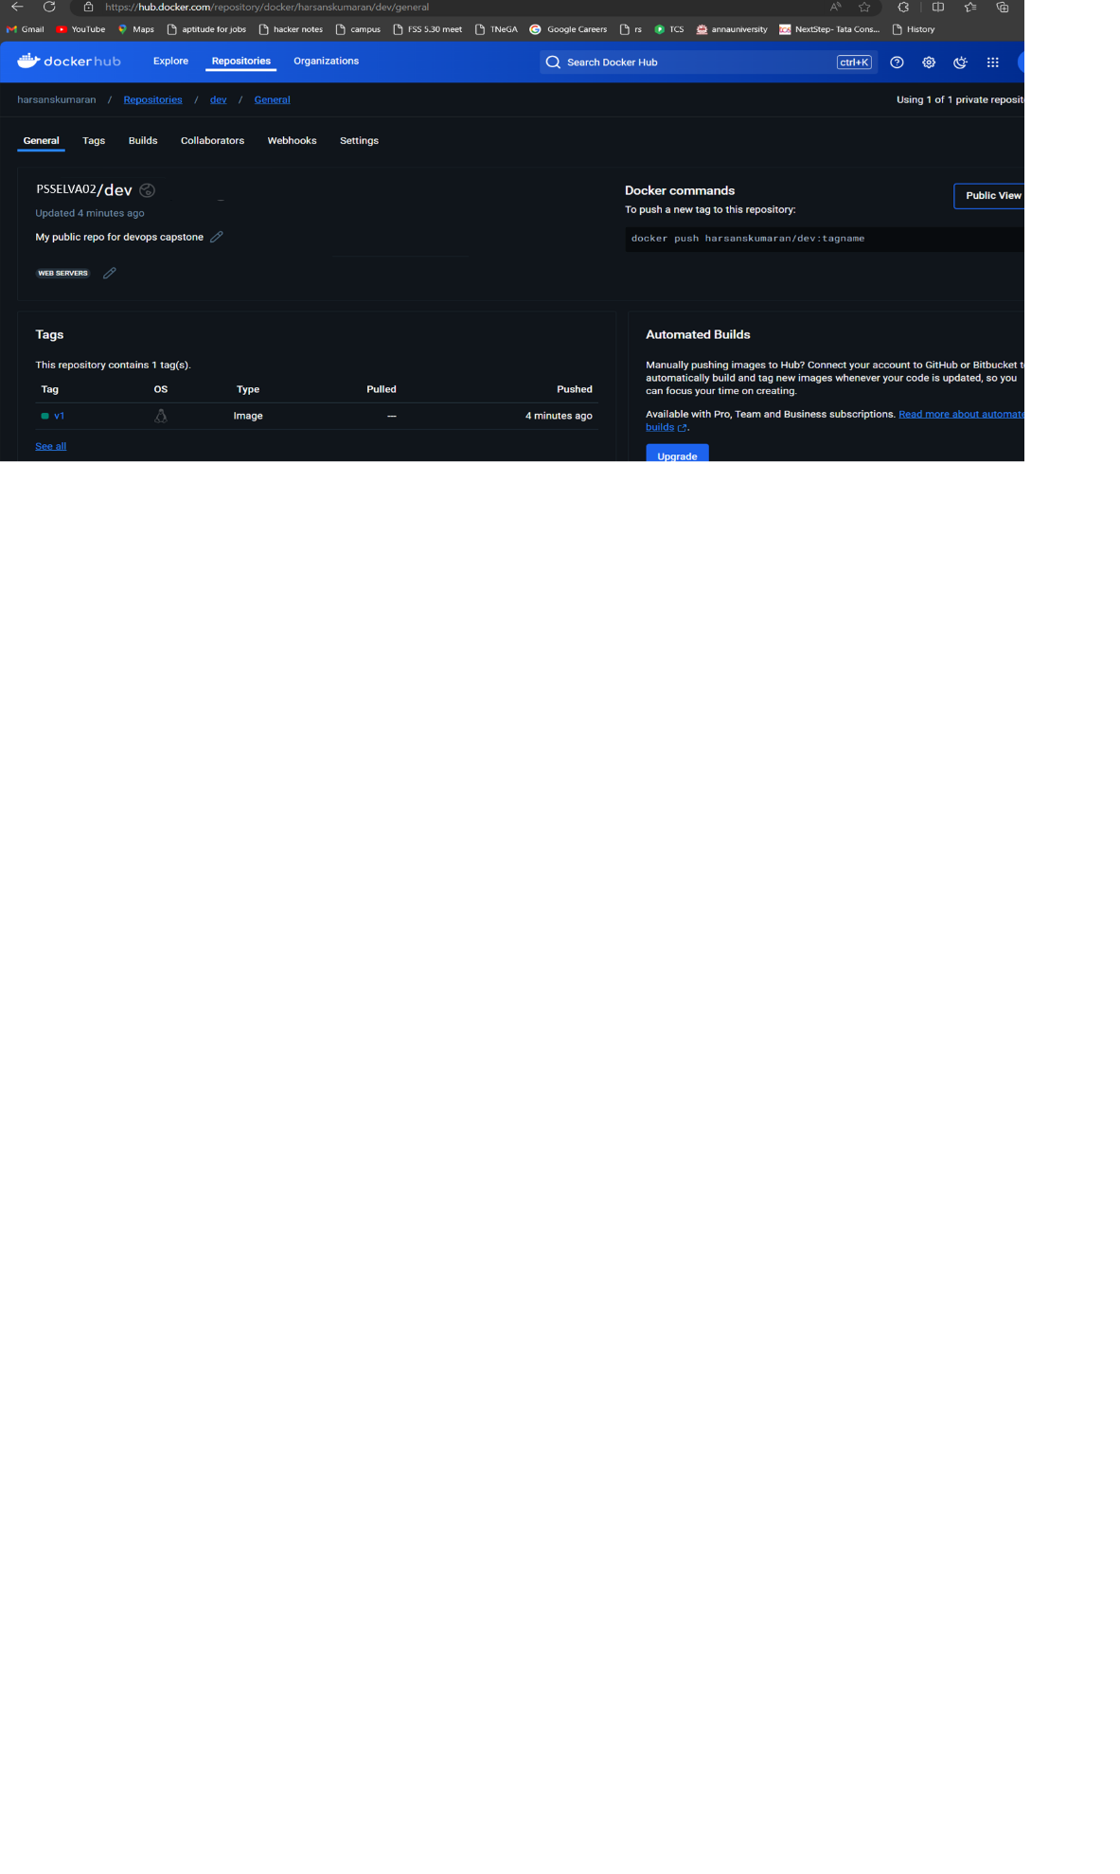

* Mail also triggered and got the build log



* **Dev build logs FYR :** [**Devops_capstone/dev_build_logs.log at dev · psselva02/Devops_capstone (github.com)**](https://github.com/harsanskumaran/Devops_capstone/blob/dev/dev_build_logs.log)

**> I have merged dev git repo to master repo, Post commit Jenkins master project as started by deploying the docker image to up the application server and pushing docker image to docker prod private repo accordingly.**



* Jenkins status

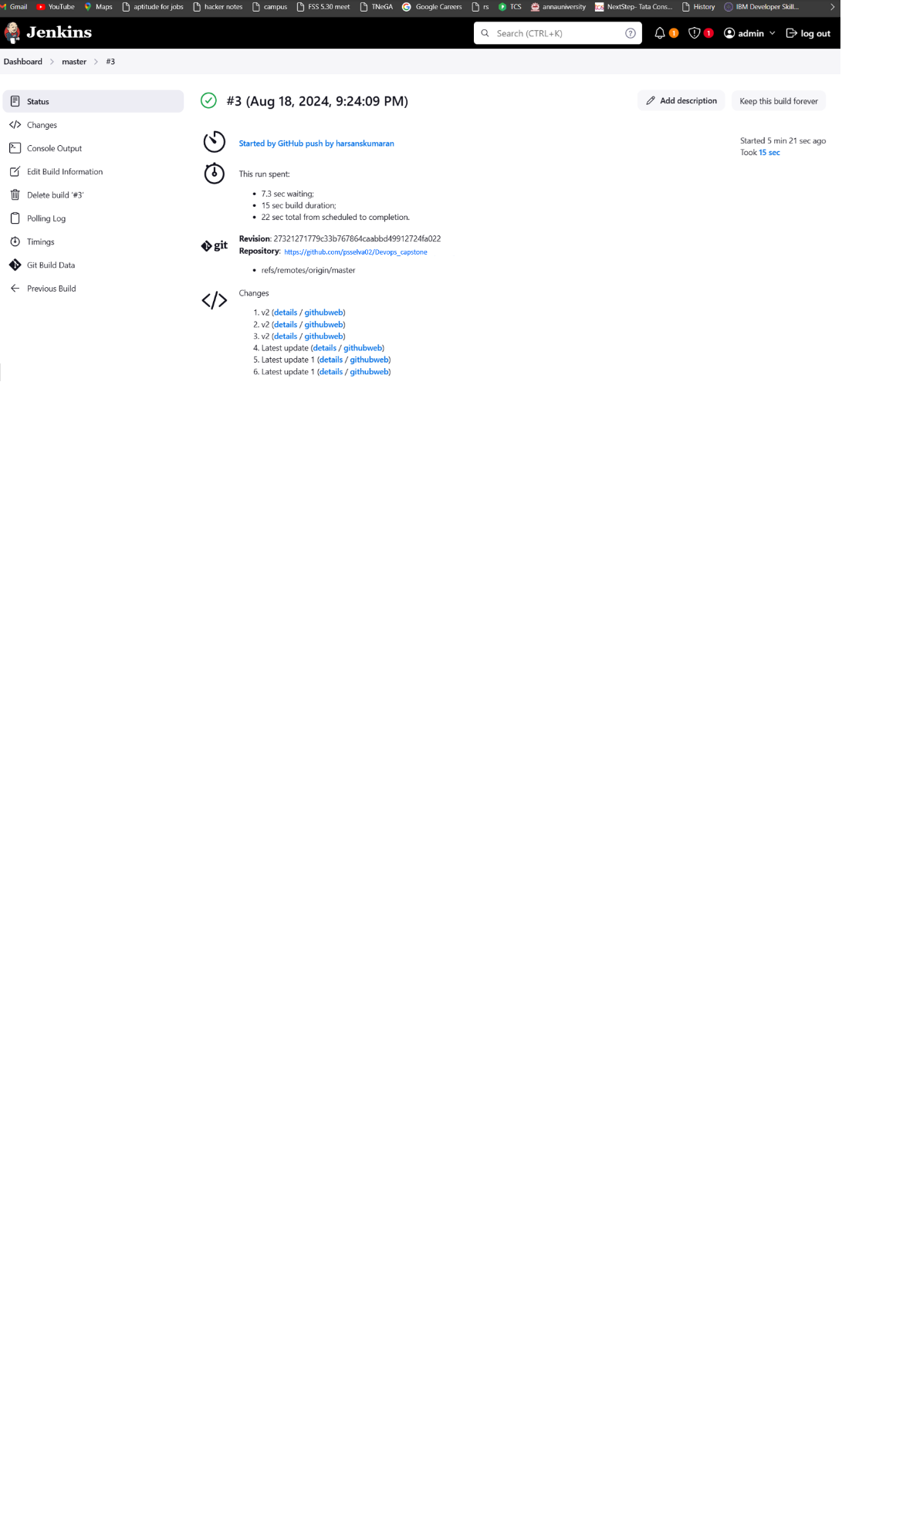

* In console application is up and running

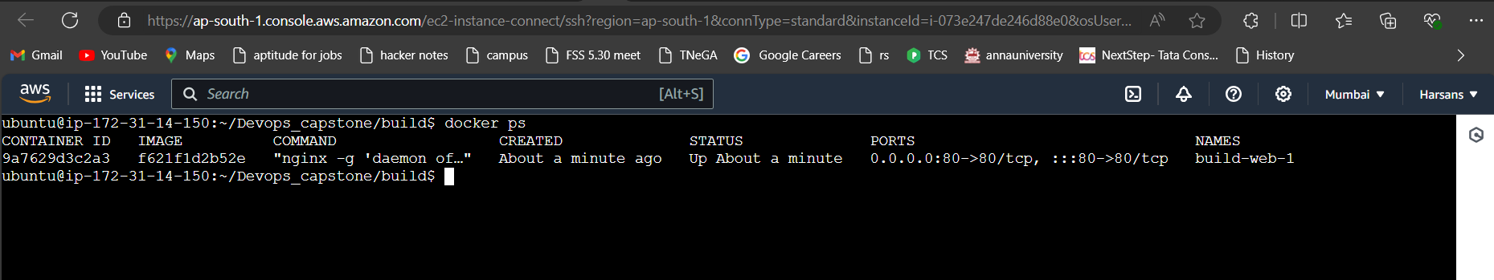

* In prod private docker repo

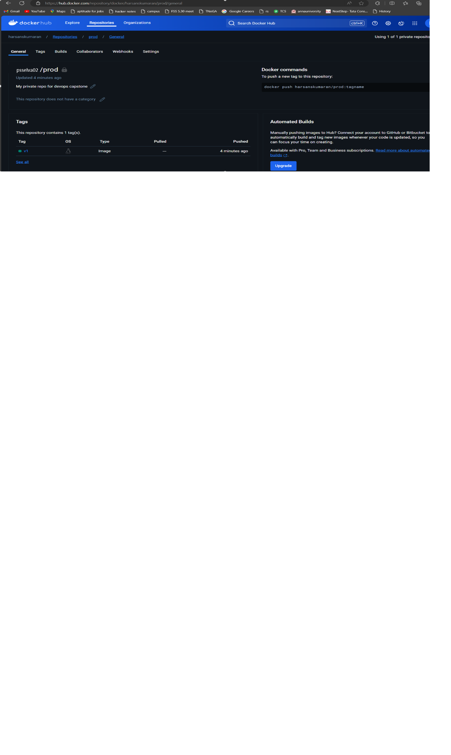

* Mail also triggered and got the build log



* **Master build logs FYR :** [**Devops_capstone/master_build_logs.log at dev · psselva02/Devops_capstone (github.com)**](https://github.com/harsanskumaran/Devops_capstone/blob/dev/master_build_logs.log)

**> Configured security groups (SG) as follows:**

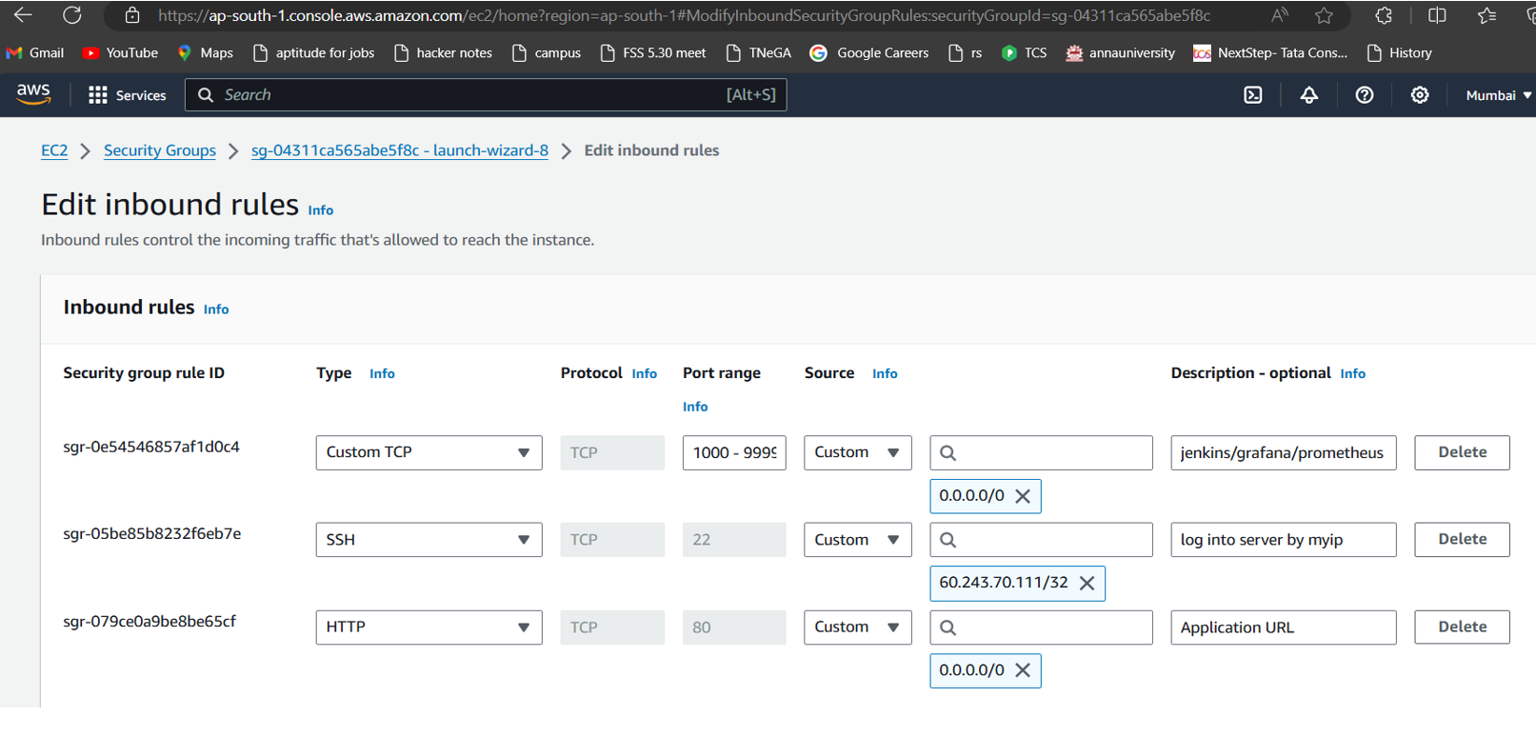

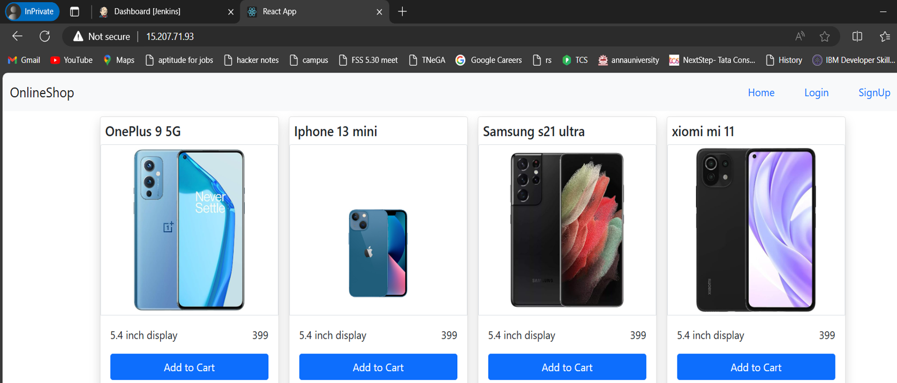

* **Allow access to the application only from IP addresses with the specified IP**



Restrict SSH login to the server to your IP address.

Myip > able to access it

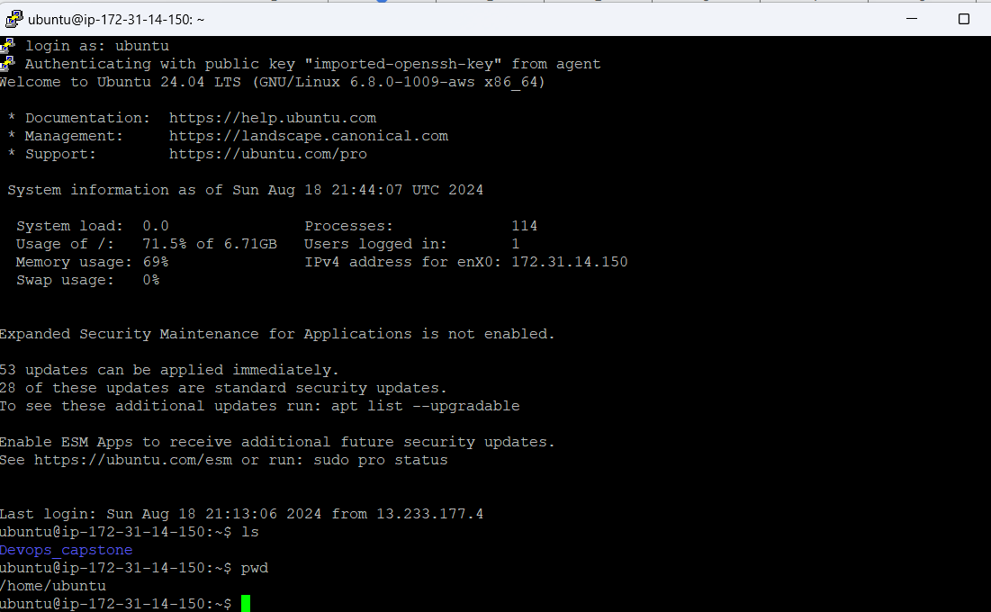

Rest of the access option has been restricted FYR

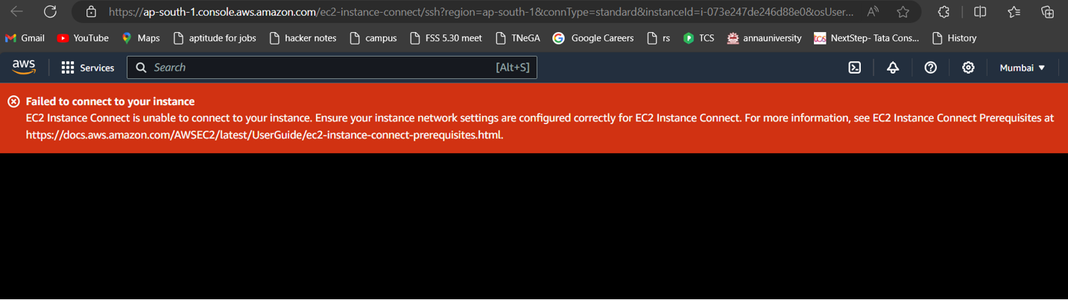

**> Monitoring:**

Set up a monitoring system to check the application's health status using an open-source monitoring solution.

There are the cmd used to set up grafana, prometheus and cadviser tool to monitor the application status : [Devops_capstone/Monitoring tool at dev · psselva02/Devops_capstone (github.com)](https://github.com/harsanskumaran/Devops_capstone/tree/dev/Monitoring%20tool)

Grafana: it displays the metrics

Note run in 3000

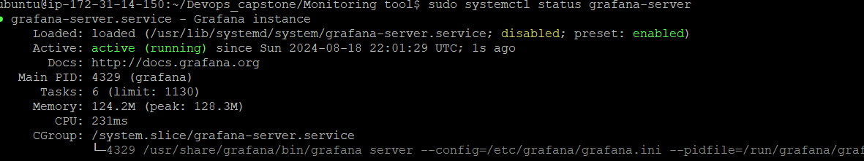

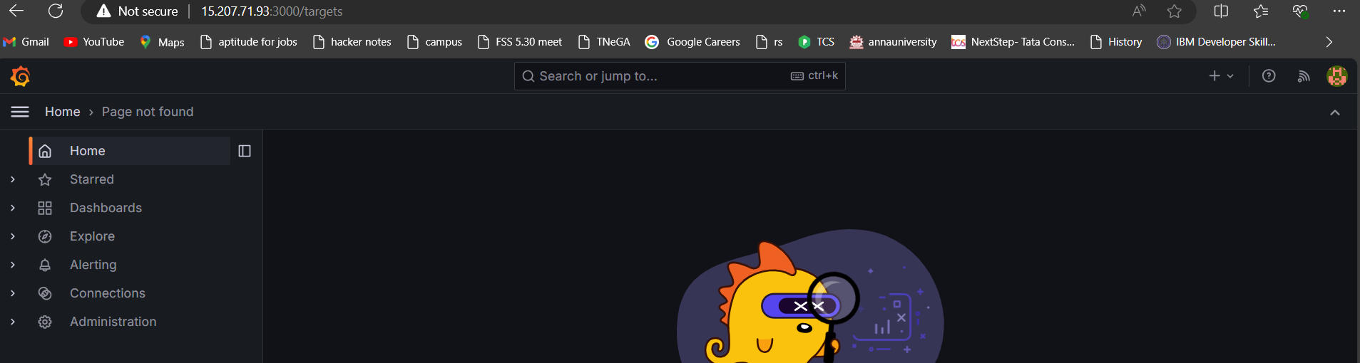

Prometheus: it scraps the metrics

It runs in 9090

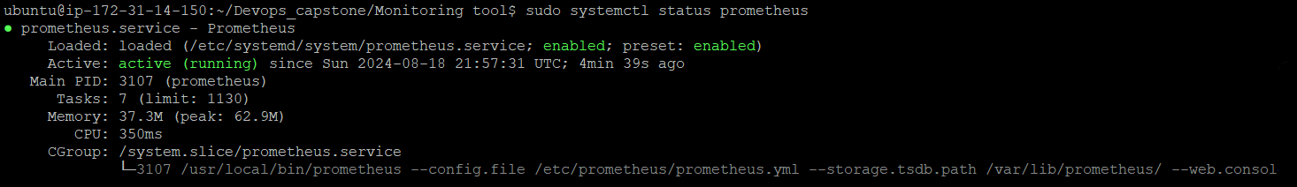

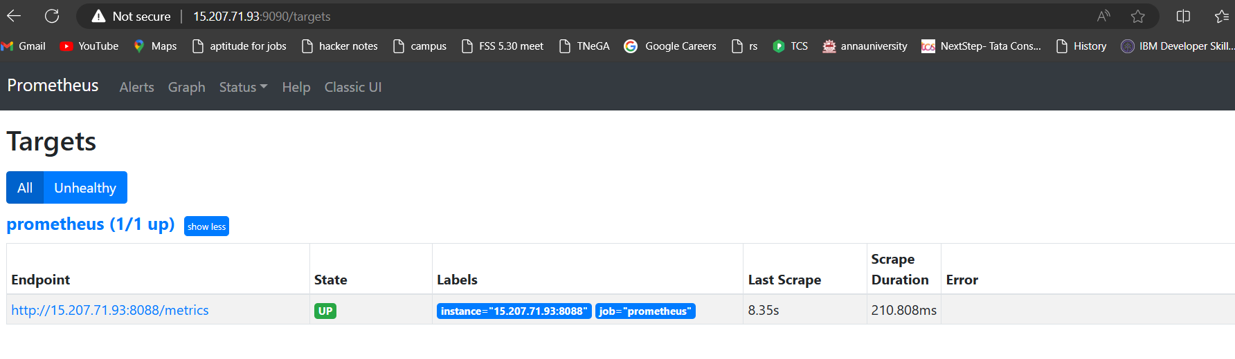

Cadviser: it collecting the metrics

it runs in 8088

sudo docker run -d --name=cadvisor -p 8088:8080 -v /:/rootfs:ro -v /var/run:/var/run:ro -v /sys:/sys:ro -v /var/lib/docker/:/var/lib/docker:ro -v /dev/disk/:/dev/disk:ro --privileged --device=/dev/kmsg --restart=unless-stopped gcr.io/cadvisor/cadvisor

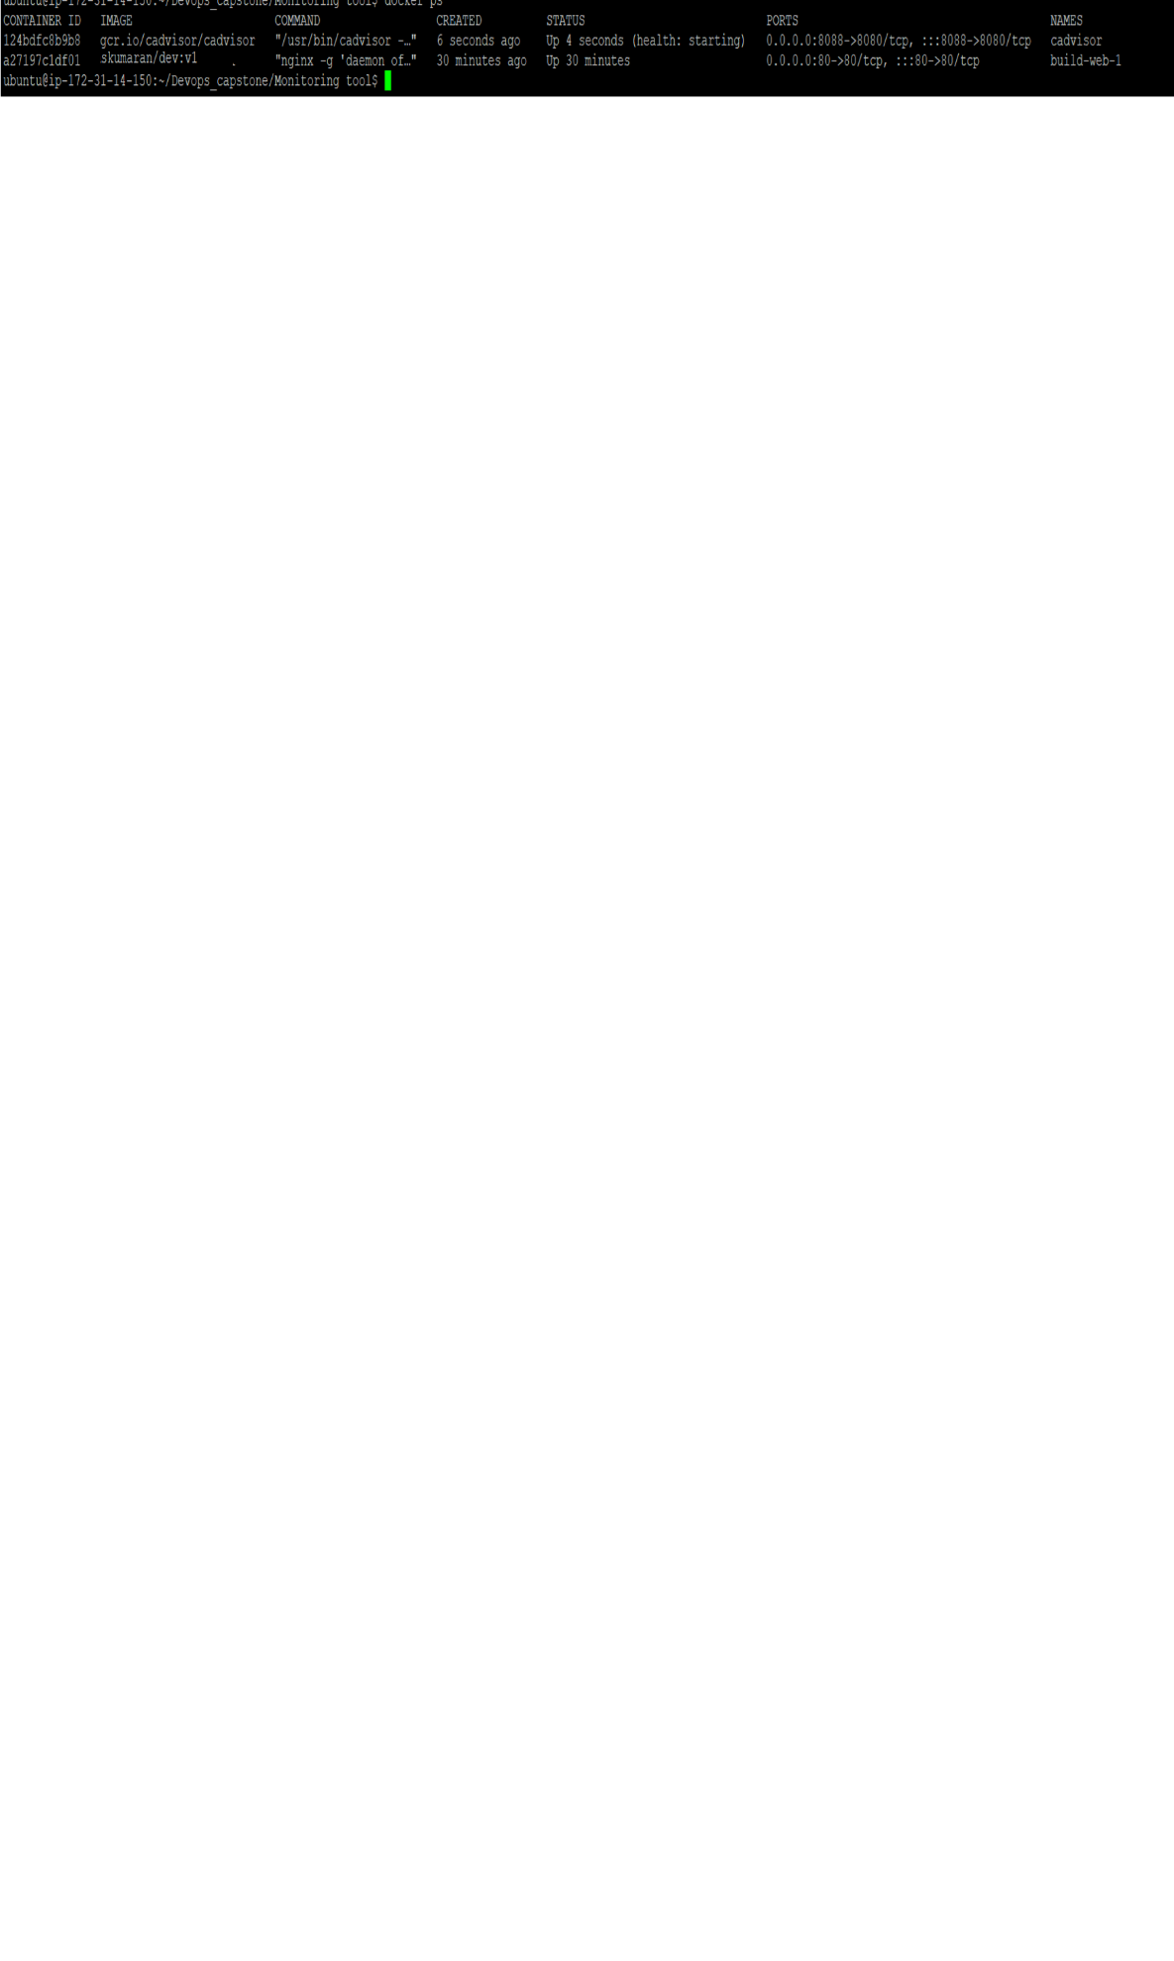

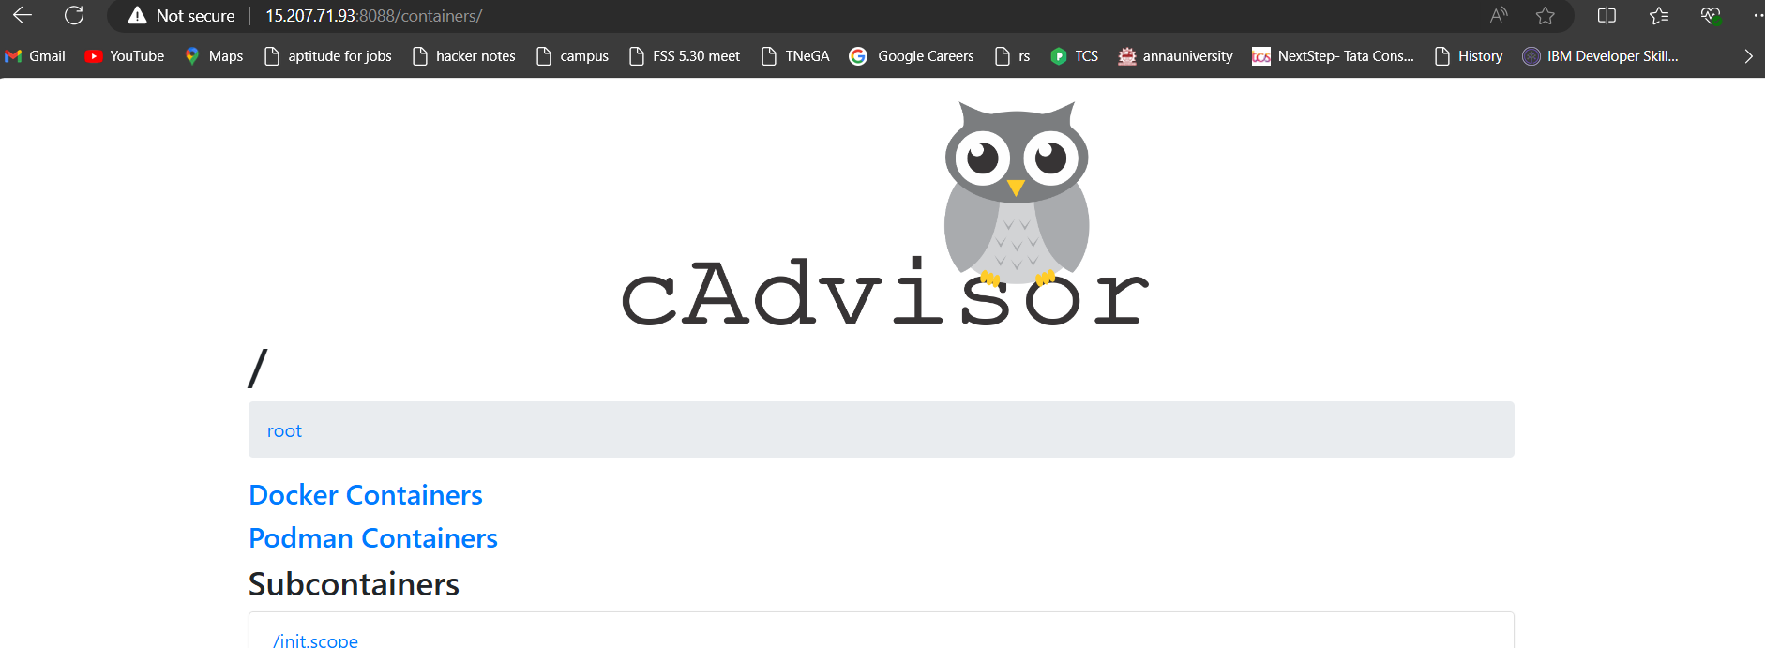

Below dashboard helps to monitor the app status

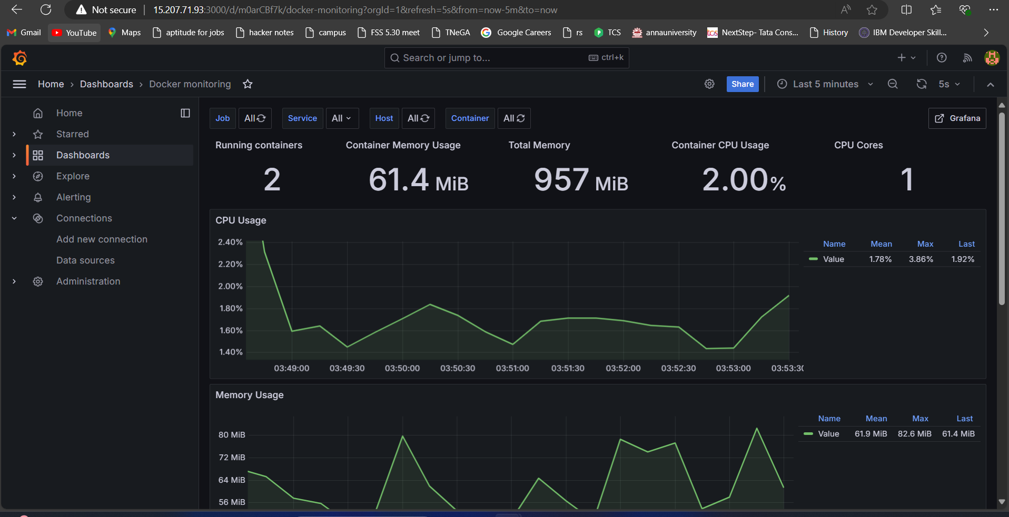

* if the application goes down it notify us.

As of now 4 container running i have set an alert if any one container goes down it will trigger the alert mail

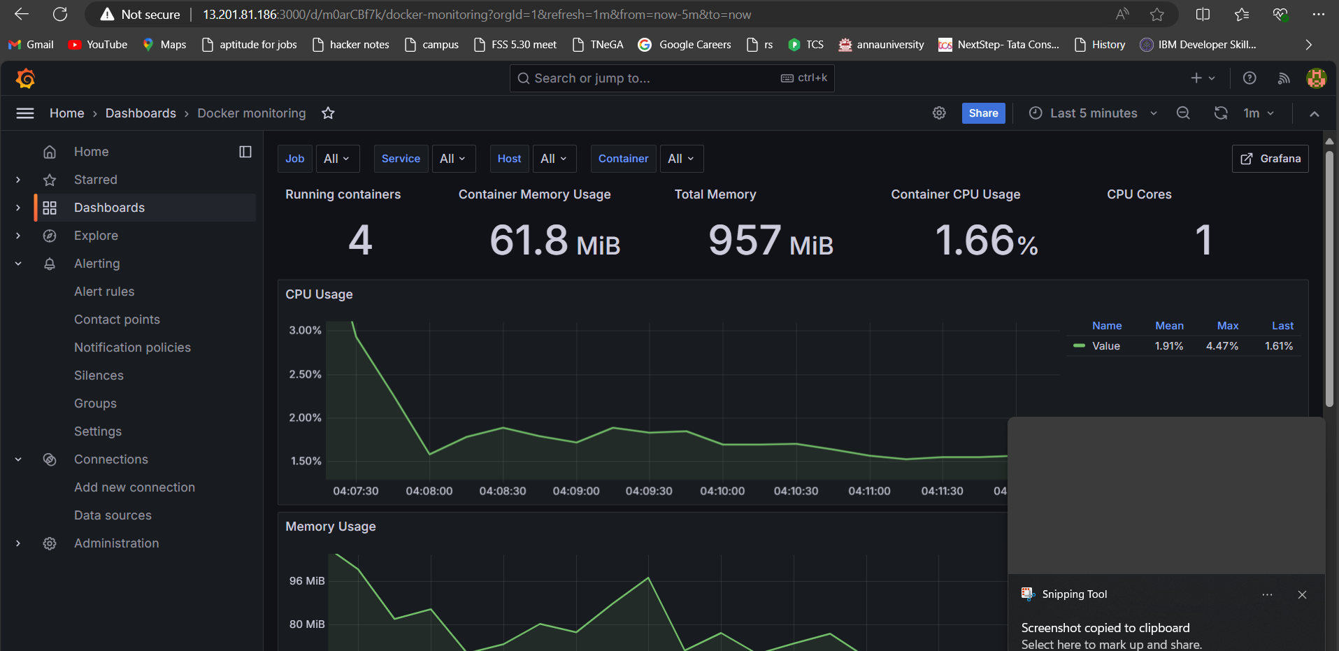

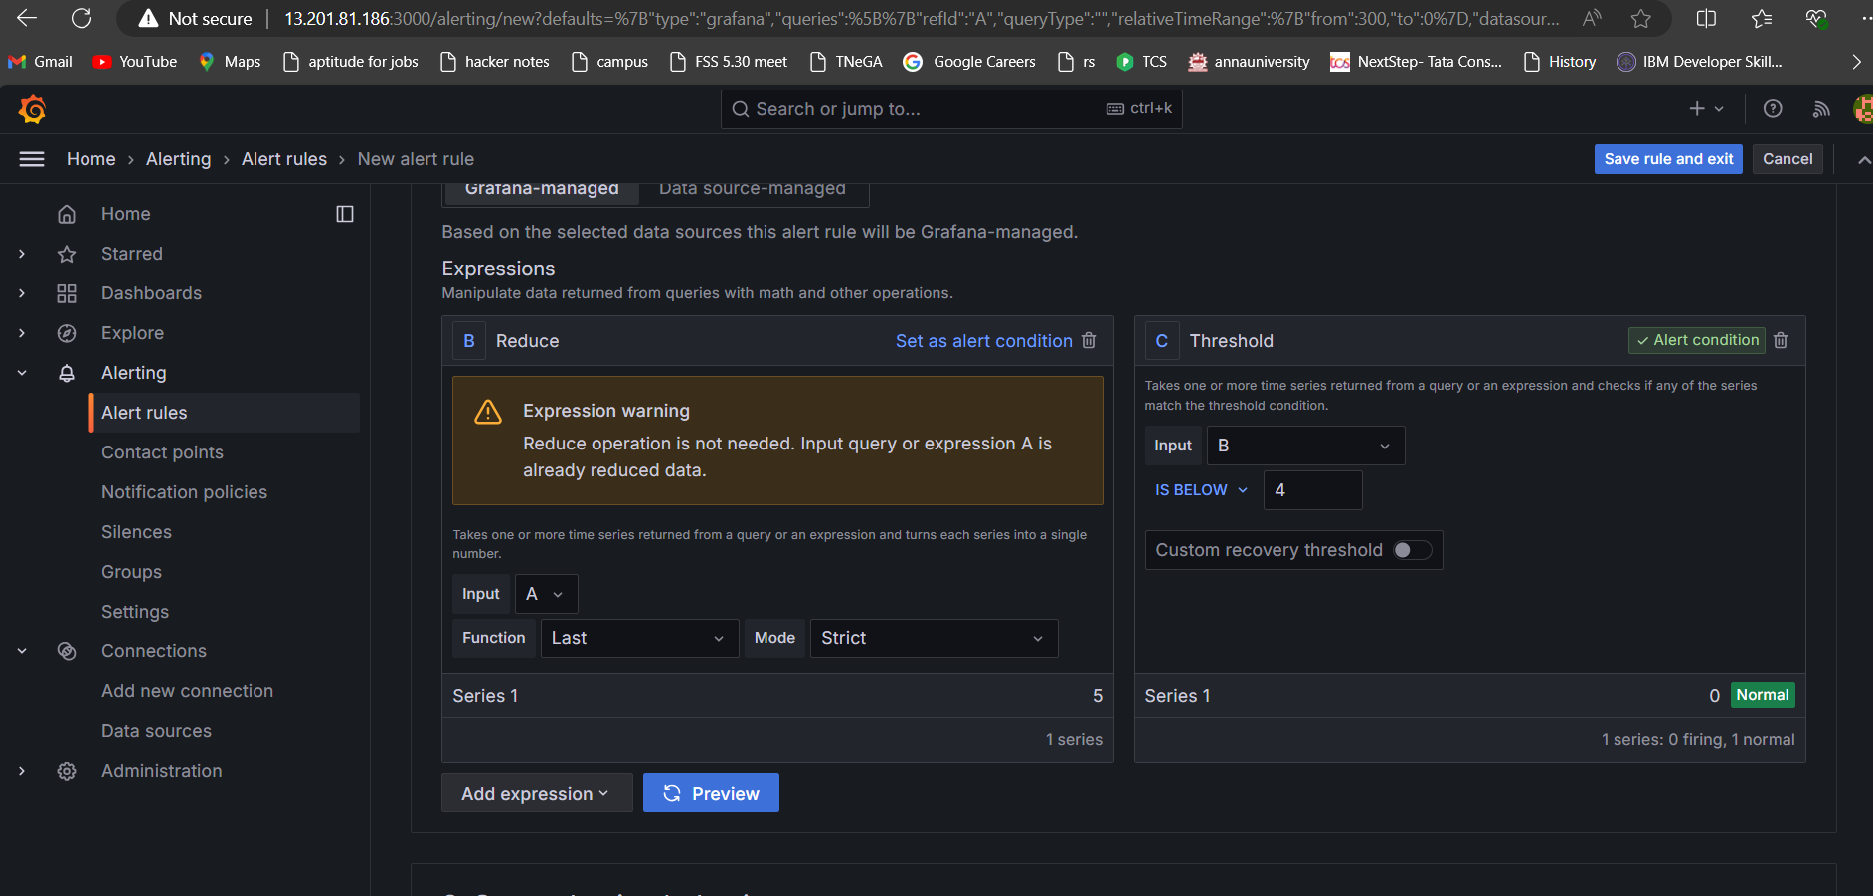

Removing one container to check alert

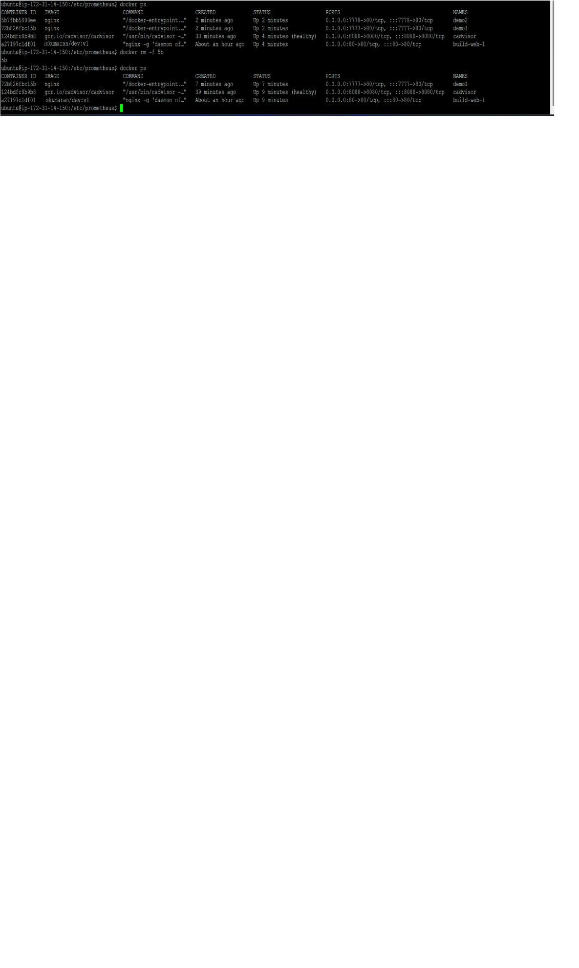

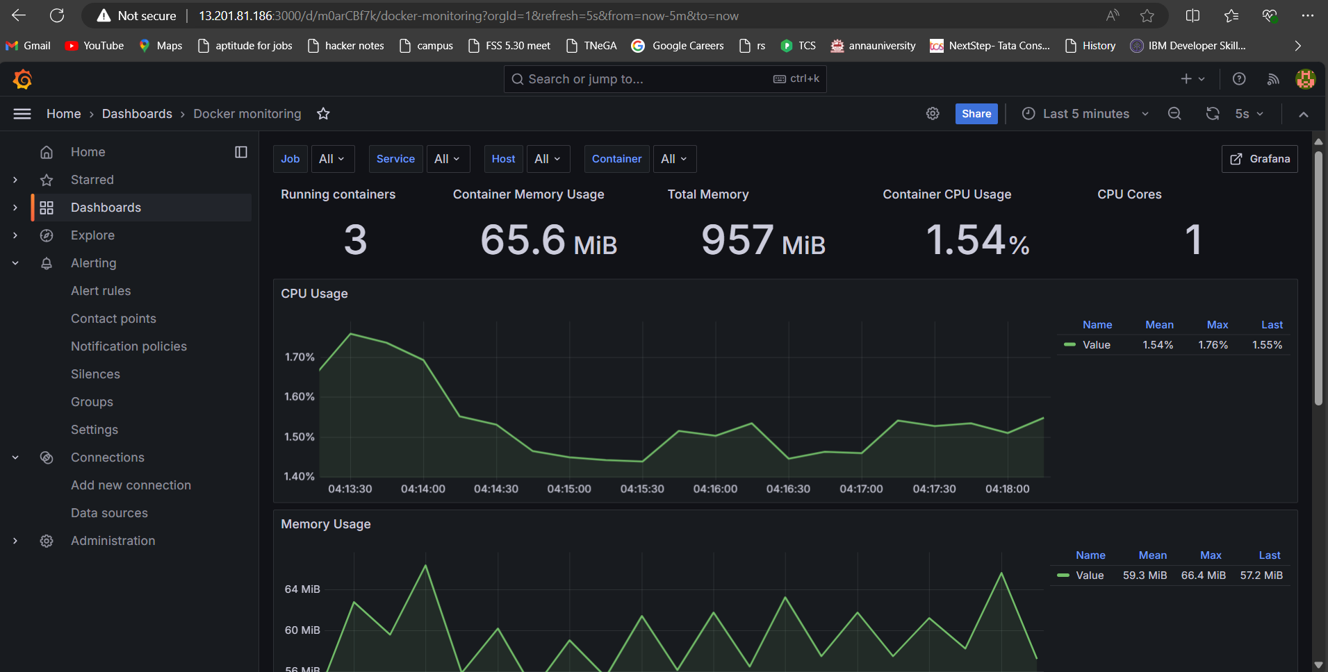

Received mail

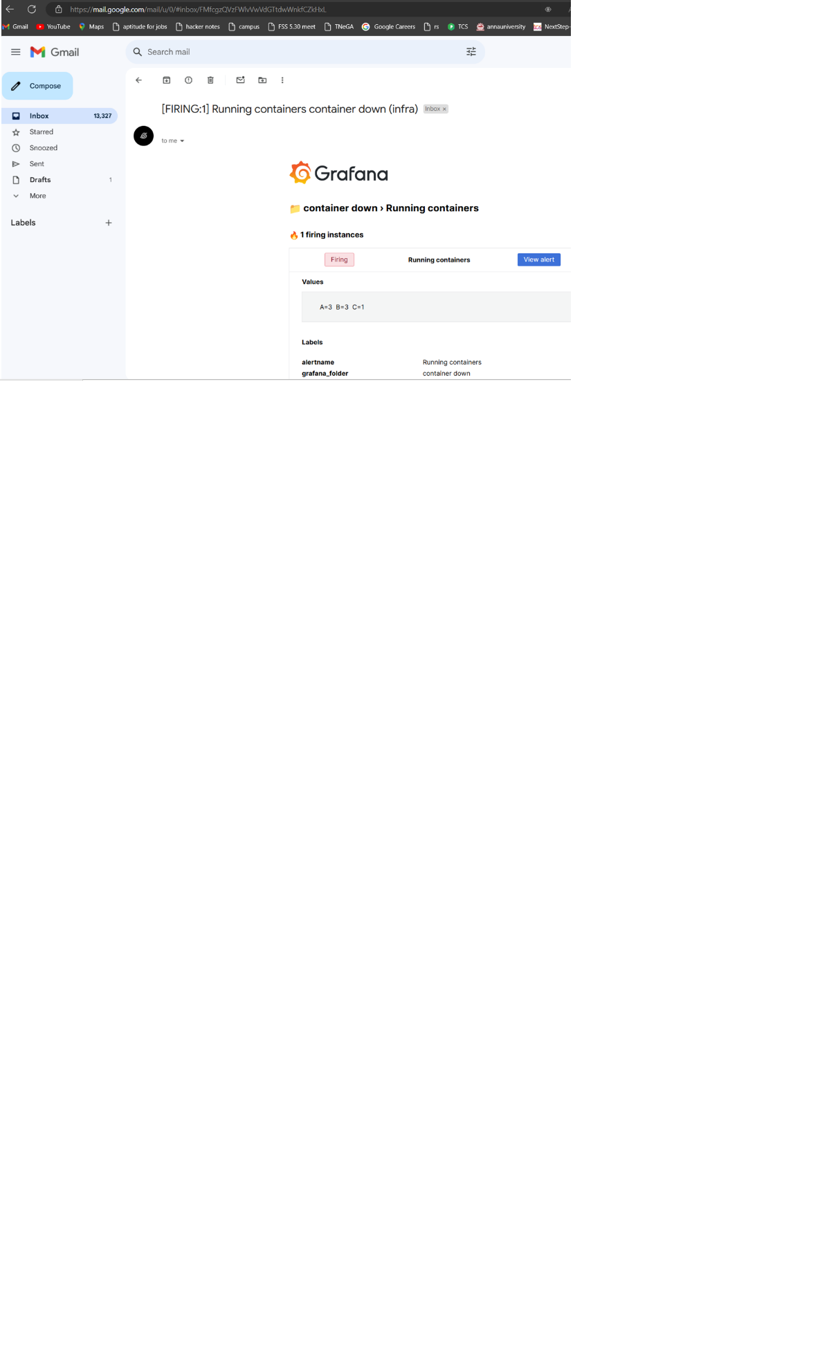

**> Submission**:

* **Git repo:** [**harsanskumaran/Devops_capstone (github.com)**](https://github.com/harsanskumaran/Devops_capstone)

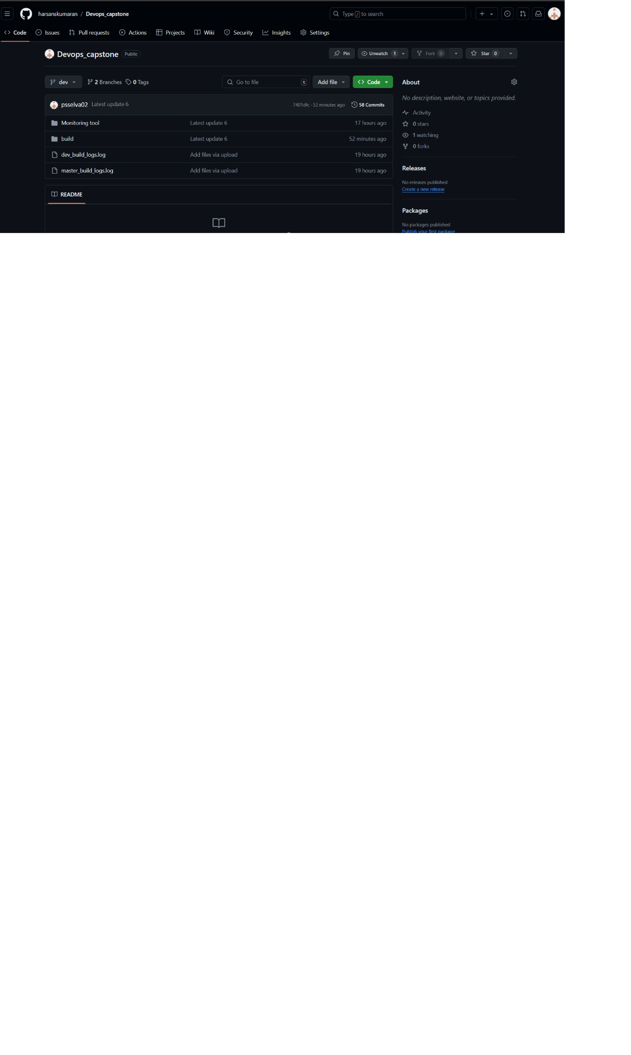

* **Docker hub URL :** [**harsanskumaran's Profile | Docker Hub**](https://hub.docker.com/u/harsanskumaran)



**> Docker image name**

**psselva/dev repo is public | psselva02/master repo is private**

* **Deployed site URL >** <http://15.207.71.93/>
* **Jenkins**

**> Login page**



Config page



Exec cmd build > [Devops_capstone/build/Jenkins-build.sh at dev · psselva02/Devops_capstone (github.com)](https://github.com/harsanskumaran/Devops_capstone/blob/dev/build/Jenkins-build.sh)

Exec cmd deploy > [Devops_capstone/build/Jenkins-deploy.sh at dev · psselva02/Devops_capstone (github.com)](https://github.com/harsanskumaran/Devops_capstone/blob/dev/build/Jenkins-deploy.sh)

* **Monitoring health check status dashboard**



Clip of application working on site have attached with : Please download and unzip to watch it> [Devops_capstone/ Application-login-video.mp4 at dev · psselva02/Devops_capstone (github.com)](https://github.com/harsanskumaran/Devops_capstone/blob/dev/clip%20of%20applicaton.zip)